IN-CLASS ACTIVITY: CARTOONS & QUOTES ABOUT & BY SCIENTISTS

Objectives: (1) To deepen your understanding of the many-faceted characteristics of the scientific process by identifying some of these aspects of science as they emerge in quotes from actual scientists and cartoons about scientists.

(2) To discuss and describe and possibly revise your view of science, based on this (hopefully) deepened understanding.

Directions: Following Dr H’s presentation on science, you will get into groups of 2- 3 students and together do PART A & PART B. After you work out the answers, you'll be asked to report your results and we'll discuss the answers as a class.

Here are some key points from Dr H’s lecture that may help you with the answers (also in CLASS NOTES p 11)

I) Science Overview
II) Methods Used:
Experiments, Observations
Standard "tools of science" -- hypotheses, prediction, testing, theories

III) Personal side of being a scientist

IV) Scientific Methods & The Nature of Scientific Research

- Traditional: observation ==> hypothesis ==> prediction ==> testing
- Delving deepr:
observations vs. experiments
hypothesis vs. theory vs. law
prediction and testing
3. One view of "formal" scientific method: 1. state problem, 2. develop hypotheses, 3. experiments to test each hypothesis, 4. predicted results, 5. observed results, 6.conclusions based on results

4 Types of reasoning: inductive (induction) & deductive (deduction)
IN-duction: individual obs ==> general conclusion
DE-duction: the big picture (theory) ==> conclusion/prediction about individual obs

How it's "really" done: weaving back & forth between induction & deduction, interconnectivity (see Pirsig essay “On Scientific Method” (under Quick Links)

5. Critiques of Science
Facts and observations can be "theory laden"

6. Important aspect of science: (Karl Popper) Theories can never be positively proven to be true, but some can be disproved by “falsifying” them.

7. Science in action: curiosity, persistence, rare discovery, communal review, cumulative enterprise, open but skeptical mind, human error or fraud gets weeded out, conflicts of interest must be noted, collaborative efforts important, wonder-awe-joy-mystery!
PART A: CARTOONS ABOUT SCIENCE & SCIENTISTS
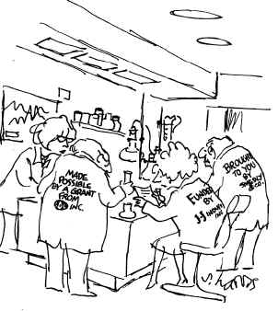
PHRASES ABOUT SCIENCE FOR MATCHING:
Match each cartoon with one of the following phrases by putting a LETTER in each blank

____ Inductive reasoning

____ Deductive reasoning

____ Ever-changing nature of scientific knowledge

____ Prediction & testing

____ Conflict of interest

____ Review of scientific results by colleagues

____ Science is a cumulative enterprise

CARTOON A

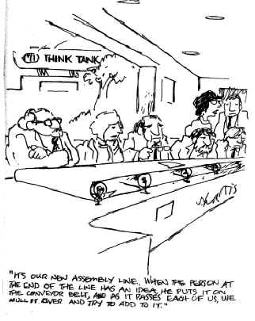

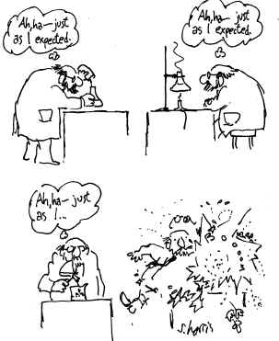

CARTOON B
CARTOON C
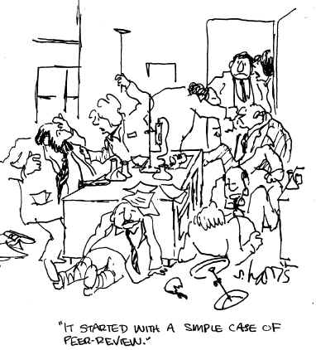
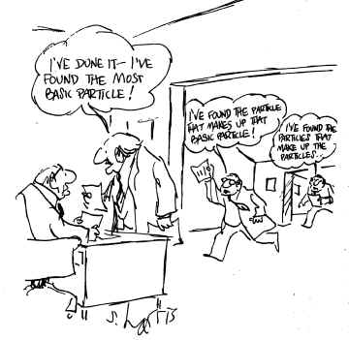
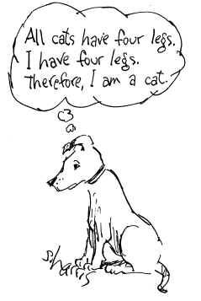
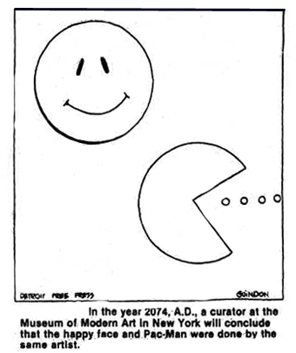
CARTOON D
CARTOON G
CARTOON F
CARTOON E

PART B: QUOTES BY SCIENTISTS ABOUT THEIR SCIENCE

Match each QUOTE with the phrase that BEST expresses an aspect of science that the scientist is talking about in his or her quote.
1. Newton's passage from a falling apple to a falling moon was an act of the prepared imagination. John Tyndall (1820-1893) Irish physicist.

2. The joy of insight is a sense of involvement and awe, the elated state of mind that you achieve when you have grasped some essential point; it is akin to what you feel on top of a mountain after a hard climb or when you hear a great work of music. Victor Weisskopf (b. 1908) Austrian-American physicist

3. Besides learning to see, there is another art to be learned -- not to see what is not. Maria Mitchell (1818-1889) US Astronomer

4. No, it's a great life. It's harder than I ever imagined, in the sense that you have to get used to wasting an enormous amount of time. You have to get the discipline of sitting at your desk fooling around with ideas that almost never work and living for the rare moment when an idea does work. Steven Weinberg (b. 1933) US physicist.

5. Ask questions. Don't be afraid to appear stupid. The stupid questions are usually the best and the hardest to answer. They force the speaker to think about the basic problem. Paul Ehrenfest (1880-1933) Austrian physicist

6. The one universal ever-operating law throughout has been the law of change. Nature never stands still and never duplicates herself. Life is always in the process of becoming something else. Laurence M. Gould (b. 1896-1995), US scientist

7. No amount of experimentation can ever prove me right; a single experiment may at any time prove me wrong. Albert Einstein (1879-1955) Swiss-American physicist

PHRASES ABOUT SCIENCE FOR MATCHING:
Match each quote above with one of the following phrases by putting a NUMBER in each blank

_____ Curiosity & self-discovery tend to motivate scientists

_____ Dedicated & persistent research yields benefits

_____ Scientists are attracted by the wonder, awe, & joy found in their research

_____ Inspiration emerges from a well-informed mind

_____ Theories cannot be verified, but they can be falsified

_____ Self-deception can color an observation

_____ Knowledge is ever-changing

