NAME: ____________________________________ GROUP:_________

DATA COLLECTION & ANALYSIS WORKSHEET
The Bristlecone Pine (BCP) Class Activity
(NOTE: Take careful notes during the class activity on this worksheet.
You will turn this worksheet in as part of your BCP Activity Write-Up. )
Members present for each day of the activity should sign in on the separate SIGN-IN SHEET on both DAY 1, Oct 7th (PARTS A & B) & DAY 2, Oct 14th (PARTS C, D & E).
Objectives:
- to learn more about bristlecone pine sites and how to collect and analyze tree-ring data from cores
- to understand the concept of pattern-matching & crossdating between trees and between sites
- to become aware of the influences of climate and elevation on trees
- to understand the methods of making a master chronology
- to discover evidence of how climate varies through time
Logistics for the class project:
Five tree-ring sites are being studied (see attached site map). There are 4 groups working on each site; two groups working on the early period of the record at a site (1750-1900) and two groups working on the later period of the record at a site (1850- present -- note overlap in record).
At each site, there are records from for 4 different trees (for groups with more than 4 members, some students will have duplicate cores) (2 cores per tree -- early part and later part of record is represented in different groups)
1 master chronology for the site (to be provided by instructor)

What you should have completed in advance:
- A skeleton plot on graph paper for your own core, marked with frost rings if applicable, & starting & ending dates
- A “site composite” with all the plots for your site properly pattern-matched, dated, & taped together

************************************************************************************

PART A -- DESCRIPTIONS OF THE FIVE BRISTLECONE PINE SITES (class presentation)

❑ 1. As you listen to the presentation on the 5 bristlecone pine sites, fill in the TABLE on the next page with information and comments about the 5 sites being analyzed by the class. You will need this information to answer questions later and for your BCP Research Reports.

BRISTLECONE PINE SITES |  | 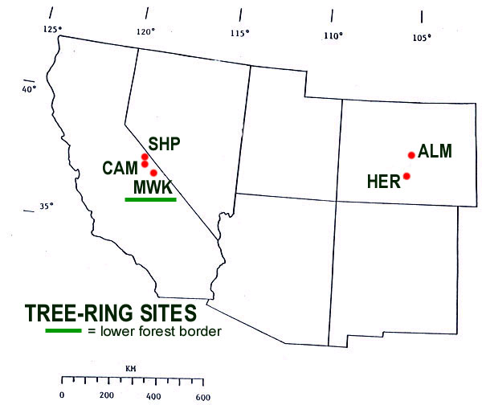
Sheep Mt (SHP)  Campito Mt (CAM)  Methuselah Walk (MWK)  Almagre Mt (ALM)  Hermit Lake (HER) | Core ID  C  D  B  E  A

VARIABLES  (NOTE: A variable is something that varies from site to site or from time to time at one or more sites ) | OBSERVATION TABLE: SITE-to-SITE COMPARISONS
 | Sheep Mt  Core ID = C | Campito Mt  Core ID = D | Methuselah Walk  Core ID = B | Almagre Mt  Core ID = E | Hermit Lake  Core ID = A
Geographic Location | White Mountains  near Bishop, California | White Mountains  near Bishop, California | White Mountains  near Bishop, California | Front Range  of the Colorado Rockies | Front Range  of the Colorado Rockies
Elevation | 3475 m  (~11,500 ft) | 3400 m  (~11,000 ft) | 2805 m  (~ 9200 ft) | 3536 m  (~11,600 ft) | 3657 m  (~ 12,000 ft)
Upper or Lower Forest Border?
Moisture- or Temperature- sensitive?
Rock / soil type | dolomite | sandstone | dolomite | granite | sandstone
# of frost rings in entire record:
Any differences in # of frost rings over time?
Describe any trends in the time series of the ring width indices:
Describe any pre- & post 1900 differences:
Describe any other interesting things you noticed about any of the sites:

PART B -- ANALYZING YOUR SITE

❑ Your Preceptor will gather together the 2 teams that analyzed the same site (the early part of the record & the later part of the record) into a SITE GROUP. Your Preceptor will present and explain the full chronology of the measured ring-width indices for your site and point out key things to notice. Discuss what you discovered about your site (e.g., variations, frost rings, and trends -- Are there differences between pre-1900 ring widths and post-1900 ring widths and frost ring frequency?)

 Enter the name of your site:

Data collection & Observations from your site’s SKELETON PLOT MASTER:
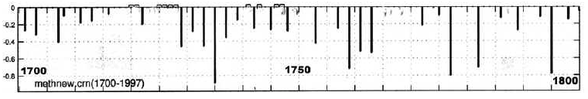
 Enter the years during which frost rings formed at your site:

Describe the relationship between frost ring years and narrow ring years (if any):

Describe differences (if any) between pre-1900 & post-1900 frequency of frost rings:

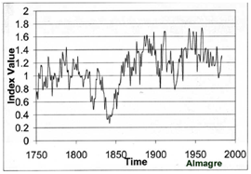

Data collection & Observations from your site’s RING WIDTH INDICES PLOT :
 Describe the variation in the time series of the ring width indices at your site (e.g., increasing trend, no trend, step change beginning at 1900, etc. etc.)

 Describe any other interesting things about your site that you observed:

PART C: ANALYZING SITE-TO-SITE COMPARISONS

❑ Your Preceptor will then provide you with the skeleton plot masters and ring-width indices for the 4 other sites so you can compare the data from site to site. Spend some time looking at all the site chronologies and reviewing the notes you took during Dr H’s presentation. Which sites appear to be similar in terms of tree growth? Which are different? What explanations can you come up with for the similarities and differences?

Now continue to fill in the observation table so that you can make site-to-site comparisons

PART D: DEVELOPING & TESTING HYPOTHESES

As a SITE GROUP, discuss and develop various hypotheses about site-to-site comparisons in tree-ring variability and what evidence of global change the trees at the study sites might contain.
(NOTE: to review what a hypothesis is, see Topic #2 in Class Notes)
IMPORTANT: A hypothesis must be stated in a way that can be tested by the available data.

Hypotheses #1 & # 2 are stated for you to get you started:

❑ Hypothesis #1: Trees in sites that are closer together will pattern-match and crossdate better than sites that are far apart.
(Discuss and figure out how to test this hypothesis. HINT: use the master skeleton plots!)

❑ Determine which sites are near each other and which are far apart (e.g. CA sites vs. CO sites), TEST Hypothesis #1 and RECORD YOUR FINDINGS HERE:

 | Results of comparison between the California sites only: | Results of comparison between the Colorado sites only: | Results of comparison between the California & Colorado sites:
Describe whether sites pattern match and/or crossdate
Is Hypothesis #1 supported?

❑ SPECULATE on what factors (similar local climate, similar species, similar elevation, etc.) might influence whether sites pattern-match & crossdate or not.

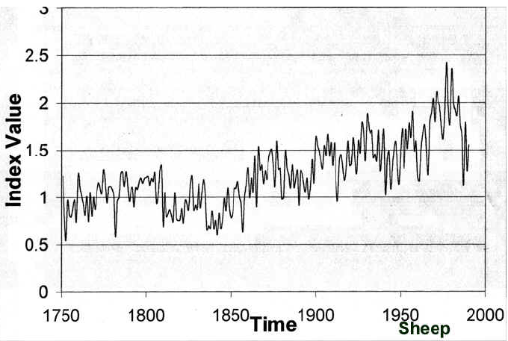
❑ Scientists have proposed different hypotheses for why the tree growth at some of the study sites exhibits a prominent increasing trend in the 1900s ,
as seen in one or more of the Ring Width Indices plots ➔

One of these hypotheses is:

Hypothesis #2: The increasing growth trend in the 1900s is evidence of a local or regional temperature response to the Northern Hemisphere / Global warming trend.

This hypothesis can NOT be tested with the data you have collected alone -- additional data would have to be collected to test it.

❑ DISCUSS & DESCRIBE WHAT ADDITIONAL DATA would be useful to test Hypothesis #2 to determine if it is correct:

❑ CONSTRUCT A TESTABLE HYPOTHESIS about Frost Rings in the trees at the study sites.

(Hints: Might the frost ring frequency be expected to change under warmer conditions? Might frost rings be expected to occur more often in some locations rather than others? Do frost rings always occur in otherwise stressful years, or stress the tree’s growth in a future year? etc. etc.)

Your Hypothesis #3:

❑ Now examine the frequency and characteristics of frost rings over time at the various sites, TEST your Hypothesis #3, and DESCRIBE YOUR FINDINGS.

❑ STATE SEVERAL EXPLANATIONS for why this hypothesis might be true or not true:

Additional notes:

