**I-4 ANSWER SHEET  
LESSON 4 INTRODUCTION TO CLIMATE MODELING**

*DIRECTIONS: Complete this answer form by typing in text wherever there is yellow highlighting: ___ Your text is not limited by the size of the yellow highlighting Your answers will be fill in the blanks, a few words, a short phrase, or a few sentences. Q1, Q4, and Q8 will require a more lengthy paragraph and will be graded on writing quality. See the grading RUBRIC posted in the D2L Dropbox for details.*

**When you are finished, SAVE the form as follows: I-4.firstname.lastname.doc (or .docx)** *(insert YOUR first & last names of course! Here’s how Stella did it: I-4.stella.student.docx*

NAME :       GROUP #:

1. [5 pts]In the description of climate models **(Slide 2)** , the tutorial says that ***“****Climate models do not rely on guesswork. They describe the climate system with mathematical equations based on* ***laws of physics*** *and solved with sophisticated computers.”*   
   We’ve covered some of the laws of physics in class this semester. By reviewing your CLASS NOTES, **select one of the “laws” we’ve covered in class that could be suitable for use in a climate model to “mimic” actual climate-related processes (for example: solar radiation, thermal energy transfer, etc**.)**Then in a few sentences of about 75-100 words, explain how this law could be used in the climate model** *Hint: Look for the word “Laws” in the list of topics in the Table of Contents in Class Notes to review them. Take care to explain the underlying science of what you are writing about correctly. [Be thoughtful and specific. Show that you spent some time reflecting on this before you began writing.]*

Stella’s Example [88 words]: *The* ***Inverse Square Law*** *could be used in a climate model to calculate the difference between the amount of radiation intercepted by Earth in January (when the Earth and Sun are closest to each other) vs. in July ( when the Earth and Sun are farthest apart.). Because the Earth-Orbital relationships of the Milankovitch cycles indicate that these distances have changed in the past, a climate model using the Inverse Square Law could tell us how the amount of radiation received by Earth was different in the past.*

1. [ 3 pts]In evaluating climate change there is a difference between **DETECTION and ATTRIBUTION**. In the yellow box next to each phrase below, **enter a “D” for those phrases which describe the DETECTION of climate change and enter an “A” for those phrases which describe an ATTRIBUTION of a likely cause of climate change***. [HINT: See the GLOSSARY in the upper right of the LESSON 4 tutorial screen to find definitions of these terms.]*  
         Measurements worldwide indicate that glaciers are melting and sea level is rising.

      Satellite images of Arctic sea ice over the past decade indicate a trend of rapidly decreasing sea ice.

      By including the natural forcing effects of sulfur-rich volcanic eruptions, computer-based climate models can replicate episodes of short term cooling for 1-3 years after the eruption year.

      Snow cover is disappearing earlier and spring is arriving earlier.

      Depletion of stratospheric ozone over Antarctica occurs in the same place and at the same time as an increase of chlorine over Antarctica.

      Ocean heat content is increasing.

1. [3 pts]In the tutorial’s discussion of **Slide 5** *(* *Example of a Climate Model )* you ‘stepped inside’ an animated climate model of changing average surface temperatures**.** The animated model showed that, over a year, temperatures over land heat up more and vary a great deal, while temperatures over the oceans change more slowly. **Explain WHY ocean temperatures change more slowly using a concept you learned in class earlier this semester.**
2. [5 pts] The tutorial’s discussion of **Slide 8** opens with a **comparison of two graphs** of temperature change over time reproduced by computer models. Also shown on both graphs are the temperature observations actually observed (the black line.)*(Similar graphs can be found on pp 72-73 of Dire Predictions)*

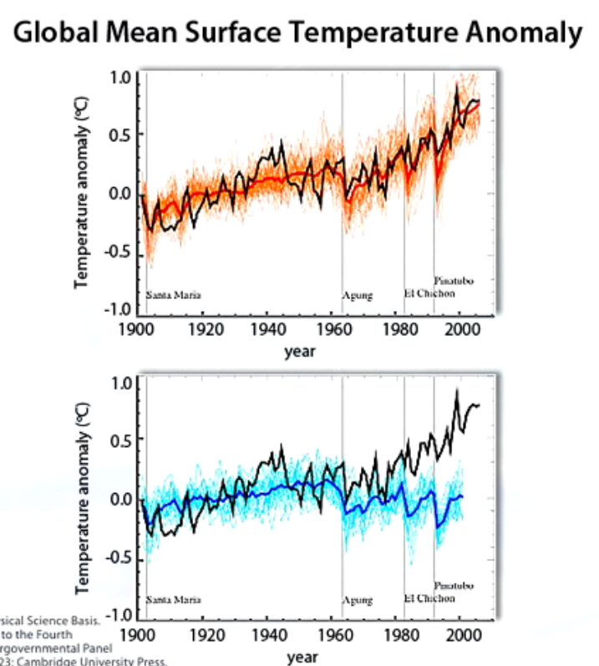

**A comparison of the modeled temperatures in the top graph (orange line) and the bottom graph (blue-line) shows that one model does a better job than the other in reproducing the observed temperatures (black line). This model comparison exercise is an example of how climate change ATTRIBUTION is done**. To get a better understanding of what ATTRIBUTION is, review **Slide 2 on “What is a Climate Model”** then go to **Slide 19 and answer Question 3**, and listen to the explanation of the correct answer.

*In a paragraph of ~75-100 words do the following:*

**Based on this attribution example, STATE which external factor or “forcing agent”** *(for definition, see GLOSSARY)* **is the “guilty” party in producing the increasing temperature trend of the last few decades. Then EXPLAIN the EVIDENCE and your REASONING for implicating this forcing agent.**

**In your answer, take care to explain the underlying science of what you are writing about correctly.** *[Be thoughtful and specific. Show that you spent some time reflecting on this before you began writing.]*

**5.** [1 pt] **According to the Lesson 4 tutorial, which of the Emissions Scenarios of the 2007 IPCC Report estimated the greatest future CO2 concentration in the atmosphere and the warmest future temperatures?** *(indicate your choice with an X in the yellow box)*

      **B 1**       **A1B**       **A2**

**Which of the 2007 IPCC Emissions Scenario “pathways” are we most likely on now?**

      **B 1**       **A1B**       **A2**

**Based on this scenario, how much warmer will the average temperature be in 2100 (compared to the year 2000)?**       **° C**

**6.** [1 pt] **Briefly describe the change in projected winter PRECIPITATION for the North American Southwest (e.g. Arizona) under the A1B** scenario of the **2007 IPCC Report** (e.g., an increase in precipitation, no change, a decrease in precipitation, etc.). *[Hint: estimate this by viewing the global AIB map in Slide 12]*     

**7.**  [2 pts ] The climate projection scenarios presented in Lesson 4 came from the 2007 IPCC 4th assessment report (AR4). Your *Dire Predictions (2nd edition)* text was published in 2015 and is based on information from the most recent IPCC Report (AR5) which was published in 2013.   
  
🡺 **According to pages 96-97 in *Dire Predictions, (2nd edition)*, how well did the earlier IPCC computer projections of CO2 increase, global warming, sea level rise and sea ice extent compare with what actually happened in subsequent years?**   
*For the items in rows (a) through (d) below, select the appropriate column by placing an X in one yellow box.*

|  |  |  |  |
| --- | --- | --- | --- |
|  | Earlier model projections exaggerated and *greatly* over-estimated the observed change | Earlier model projections were consistent with the observed change  (within a range) | Earlier model projections were too conservative and under-estimated the observed change |
| **a) CO2 increase:** |  |  |  |
| **b) Global warming:** |  |  |  |
| **c) Sea level rise:** |  |  |  |
| **d) Sea ice extent:** |  |  |  |

**8.**  [5 pts]  **In Question 4 of “TEST YOUR KNOWLEDGE”** at the end of the tutorial**, Slide 20** lists three **implications** that can be drawn about **how climate will change based on the future emissions scenarios of the climate models**.

**In a paragraph of ~75-100 words, explain what YOU personally think is the most important insight that LESSON 4 reveals about global climate change, what the future holds, and what we can – or cannot – do about it. Take care to explain the underlying science of what you are writing about correctly.** *[Be thoughtful and specific. Show that you spent some time reflecting on this before you began writing.]*